**ECE124 Lab 4 Report**

**Group Members:** Muhammad Bilal Saleem: *20661697,* Daivik Goel: *20649169*

**Group Number:** Group 6

**Session Number:** 203

**VHDL Code**

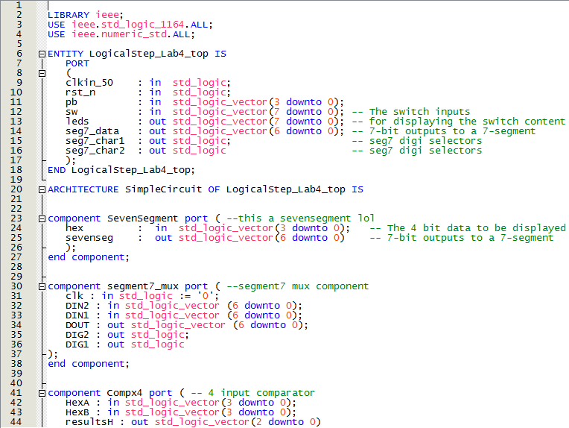LogicalStep_Lab4_top.vhd

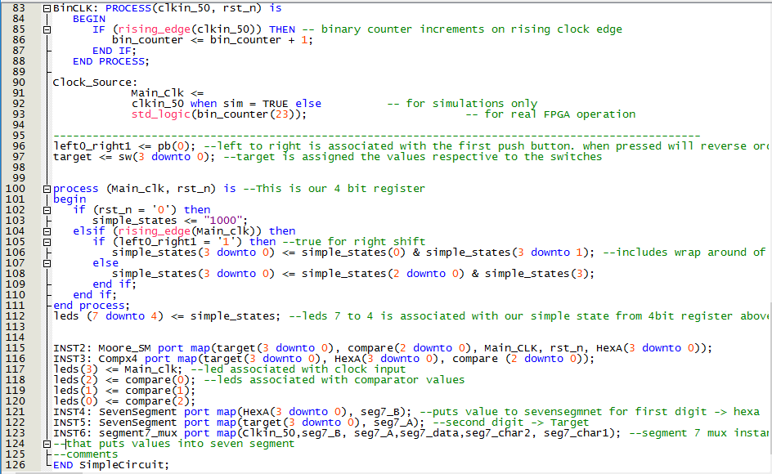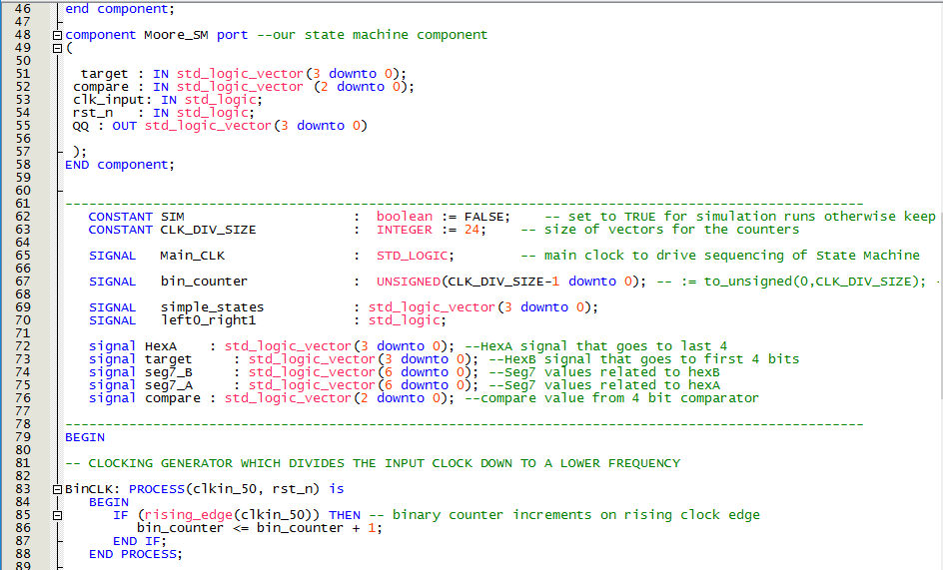

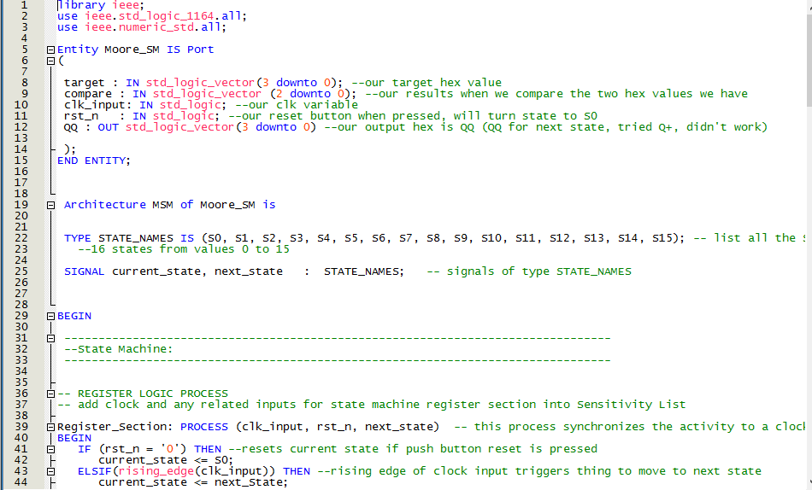Moore_SM.vhd

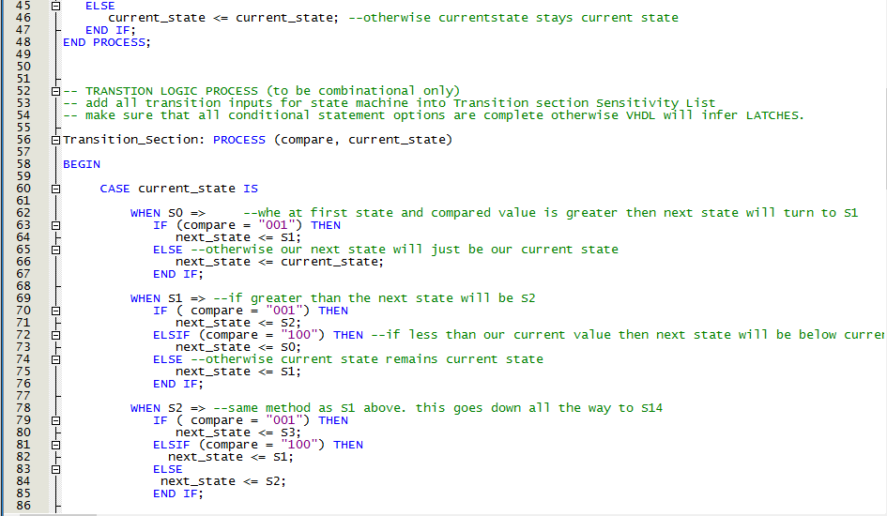

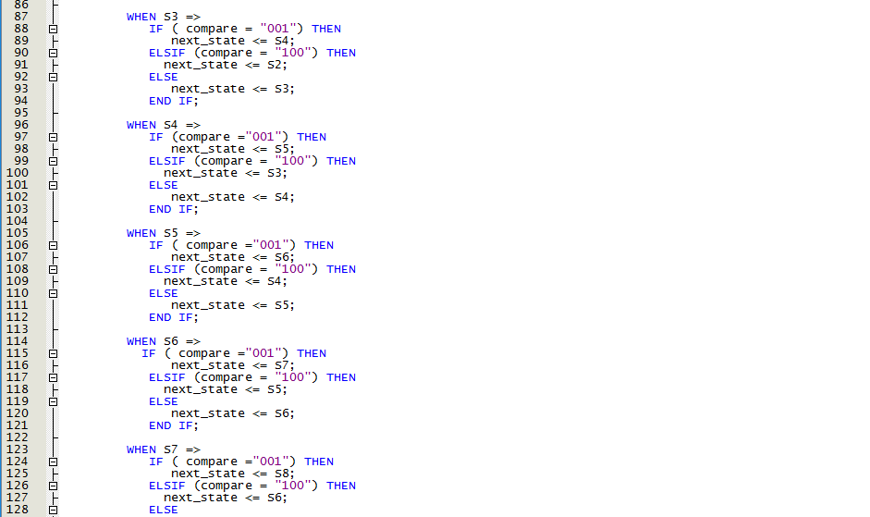

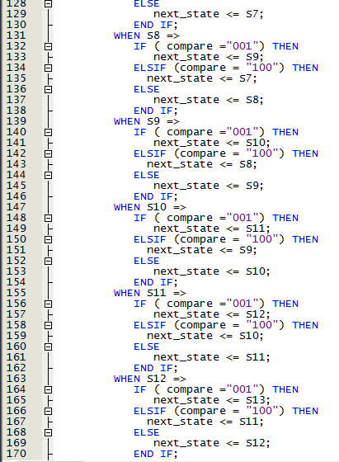

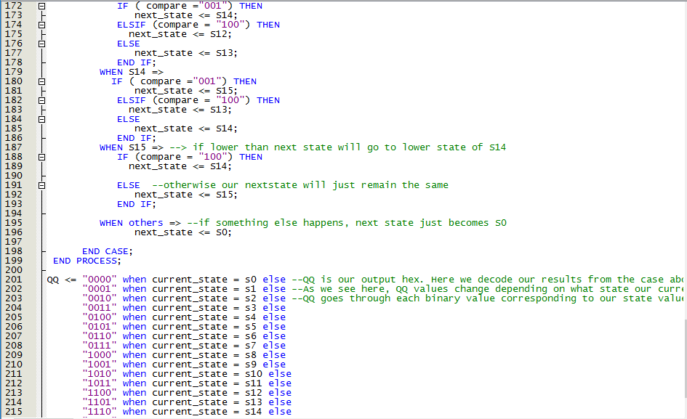

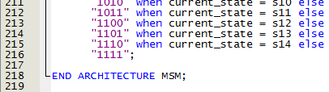

Compilation Report

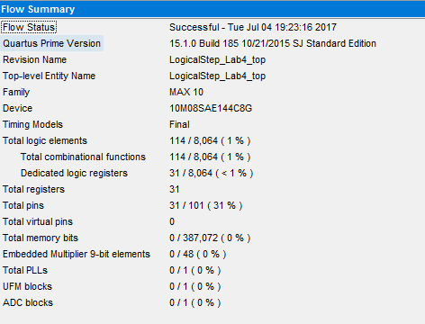

114 total logic elements are used in this design and we use 31 total logic registers. Fitter Report is at the bottom and describes total elements/registers from each component.

State Machine Diagram

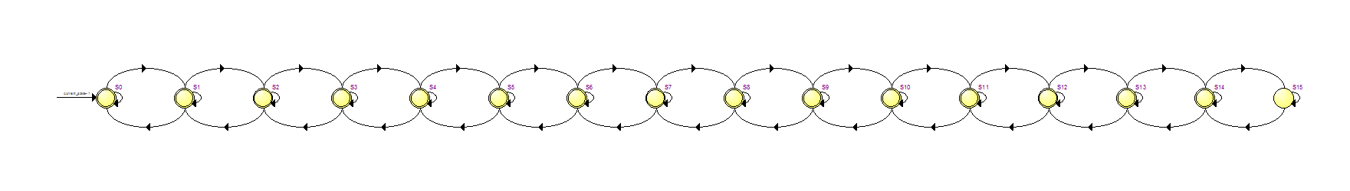This is our state machine diagram. The purple text is supposed to be our different states starting from S0 and goes to S15. Our input is our current state. States change depending on the value of the comparator. If it was “100” it would go to the next state, if it was “001” it meant it was greater than the target thus it would go to the state before the one it was currently at. If the comparator was “010” it meant the values were equal and the state would stay at the same place it was before.

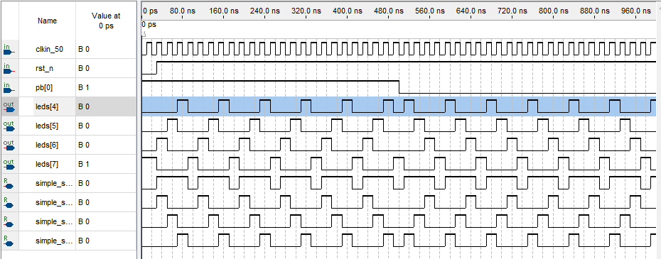4 Bit Register Simulation

This is our 4 bit register simulation. We can see when the push button that involves switching our direction of our led order is not pressed. When not pressed the leds increment based on binary value and when pressed it reverses to decrementing based on binary value. Clk is just has period of 20. We can clearly see the leds start turning on the other direction when the push button is pressed down compared to when it is not pressed. Simple_states is just showing how our registers are changing and changes direction with direction control as well.

SIMULATION STATE DIAGRAM

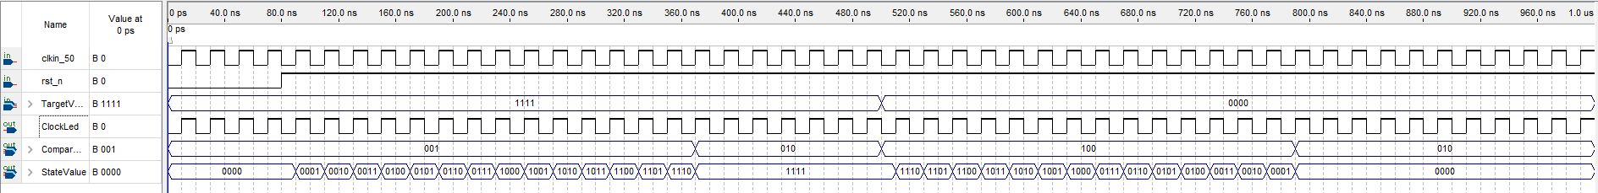

These are our Simulations for our state diagram. Rst_n is the reset button. We see at the start of our simulation, when pressed, our state machine stays at state 0. TargetValue is the set of switches that indicate the desired target value we want our state machine to climb to. CompareLeds are the leds from 0 to 2 which indicate if our value is increasing, equal or less than. The compare led values will be “100” if the statevalue is greater than the target, “010” if the statevalue is equal to target, and “001” if state value is less than target value. StateValue is just the value our state is in. This value is in binary but you can still see the states increase slowly to our target value. CLKin is just our clock value. Our period is 20. ClockLed is just linked to the clock thus they are the same. Added in simulation to show it is working correctly. Since our state machine is rising edge, whenever the clock value rises, the state machine will update (this is evident when we change our target value from 1111 to 0000, the state value doesn’t change until the clock rises again).

FITTER REPORT

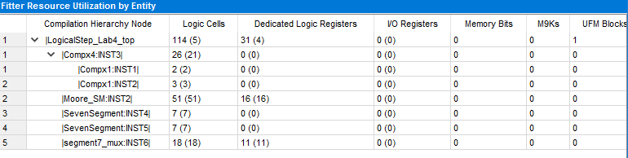

There are 114 logic cells (5 extra ones unique to top) for the top file with 31 dedicated logic registers (4 unique to top) total as seen in our total compilation report above. Our Moore state Machine has 51 Logic Cells with 16 logic registers. Our 4 bit comparator uses 26 elements (21 unique to 4 bit comparator) and the two instances of our 1 bit comparator inside use 2 and 3 logic shells respectively. Our two seven segments use 14 with each using 7. Segment 7 mux uses 18 logic shells with 11 logic registers.